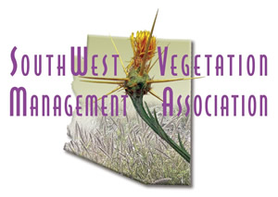

Southwest Vegetation Management Association
Annual Meeting Scholarship

Applications due: Thursday, October 19, 2017

Southwest Vegetation Management Association (SWVMA) is announcing FREE REGISTRATION to the annual meeting for up to five people, in exchange for three hours of volunteer work/each during the conference. Volunteer work may consist of booth set-up assistance, registration check-in assistance, cleanup, etc. The scholarship competition is open to all and will cover meeting registration costs only; all travel, lodging and per diem costs associated with attendance at the SWVMA Annual Meeting will be the responsibility of the recipient.

If you would like to apply for an SWVMA Annual Meeting Scholarship, please answer all the following questions below and submit by Thursday October 19, 2017 via email to: natalie_pyrooz@nps.gov

Please answer all of the following questions in a word document. You may also submit the answers as text within an email message.

General Information:
- Full Name (first and last)
- Phone Number
- Email Address
- Occupation/Employer

Interests:
- Why is this scholarship important for you to attend the SWVMA Annual Meeting?
- What are your academic/professional interests?
- What are your educational/professional goals?
- How will attending the SWVMA Annual Meeting enhance your ability to attain your educational/professional goals?
- What do you expect to learn from attendance and participation at the SWVMA Annual Meeting?

